**Pharmacy management system**

**Phase 1: Software Engineering Project**

**Submitted To**

Dr. Reham Adel

TA. Mai Mohamed

**Submitted By**

|  |  |  |
| --- | --- | --- |
| **Student ID** | **Student Name** | **Section Number** |
| **42110462** | **Eslam Ali Ahmed** | D3 |
| **42110179** | **Ahmed Hesham Abdelfattah** | A1 |
| **42110277** | **Mirna Hatem Mohamed Abu-Omar** | D3 |
| **42110014** | **Mariam Mohamed Ebrahim** | D3 |
| **42110245** | **Lamia Ahmed Mostafa** | D3 |
| **42110326** | **Solafa Ibrahim** | D3 |

**Contact Email:** 42110462.Eslam@acu.edu.eg

# **Introduction**

Pharmacy management system is a desktop application that is designed to improve accuracy and to enhance safety and efficiency in the pharmaceutical store. It is a computer based system which helps the Pharmacist to improve inventory management, cost, medical safety etc.

The pharmacy is divided into several departments Each section has a set of features:

Suppliers: the system provide collecting all details about the suppliers(phone number, national id, name) and choose from it depending on the offers and prices as well as the how fast they are in delivering the products and they also accept taking the expired medications. The pharmacist pays to its suppliers according to their desire, if it is in cash or by credit.

Purchase &sales: The system provide the pharmacists to enter the name of the medication and its quantity and will alert (pharmacists assistant) to make allergy test for specific medications as it also will show pharmacists the alternative medicines if a specific medication is out of stock and will make a special sales list for the medication which contain a percentage of drugs.

(pharmacists assistance doesn’t have authorityto open this list).

Accounting &Finance: The system provide to take all details about patients(customer) (name, phone number, address) and this details is benefit for making discount and for deferred payment and it will alert the pharmacist of the upcoming salary payment date also system provide to compare between weeks, months, years, days to know net profit or sales percentage and will also show the pharmacists all details that the pharmacist chose to compare.

**1.1 Purpose**

The purpose of this project is to develop a software for the effective management of a

pharmaceutical store that will be able to achieve the following objectives

It provides the pharmacists with ease and convenience to get all the details on all pharmaceutical products & supplier at any time accurately.

Provides all the patient's requirements in terms of safety, health and safety

* 1. **Scope**

1. The system of this project is limited to all pharmaceutical products and since we are in a modern society that is constantly evolving so we have established a management system based on improving the efficiency of the pharmacy.
2. The system will contain all information about pharmaceutical purposes, including recording the date of production, expiry and quantity.
   1. **Definitions, acronyms, and abbreviations**

# **2. Requirements**

**2.1 Functional Requirements**

**2.1.1** *Registration***:**

|  |  |  |  |
| --- | --- | --- | --- |
| Code | Requirements statements | Must / should | Comments |
| FR001 | It requires the admin user name, phone, number, email, address, and to create a password. | Must | The admin data will store in the data store to check the data from it when logging in |
|  |  |  |  |

**2.1.2 Login:**

|  |  |  |  |
| --- | --- | --- | --- |
| Code | Requirements statement | Must /should | Comments |
| FR002 | This requirement the admin to enter his email and password. | Must | After creating an account the admin enters his data then it will be checked if it is found from the data store if it is you should return to sign up |
| FR003 | This requires the user to enter his email and password | Must |  |
|  |  |  |  |

**2.1.3 Logout:**

|  |  |  |  |
| --- | --- | --- | --- |
| Code | Requirements statements | Must / should | Comments |
| FR004 | The user of system must be able to log out from system | Must |  |
|  |  |  |  |
|  |  |  |  |

### **2.1.4 Medicines**

|  |  |  |  |
| --- | --- | --- | --- |
| **Code** | Requirements statement |  | Comments |
| FR005 | The system will arrange the medicines in alphabetic form. | Must |  |
| FR006 | The system will store every detail about the medicines, for example medicine name, medicine, serial number, medicine amount, medicine price, medicine stock number, medicine expire date, medicine category. | Must |  |
| FR007 | The system will store the alternative medicines for any medication | Must |  |
| FR008 | The system will store the quantity for the medications. | Must |  |
| FR009 | The system will send alert message for the pharmacist to show that the quantity of the medicines almost sold out. | Must |  |
| FR010 | The system will allow the pharmacists to store the stock of the medicines manually. | Must |  |
| FR011 | The system will allow the pharmacists to register the expiration date and the production date of the medication. | Must |  |
| FR012 | The system will send alert message for the pharmacist to show the medication that will almost expire. | Must |  |
| FR013 | The system will automatically filter the medication. | Must |  |
| FR014 | The system will make a list for the medications that will sold out soon after filtering. | Must |  |
| FR015 | The system will make special sales list for specific medicines (drugs). | Must |  |
| FR016 | The system will send alert message for the pharmacist assistant to inform her to make allergy test. | Must |  |
| FR017 | Once the system will registered the name of the drug it will be give a special code. | Should |  |
| FR018 | The system will send warning message for the pharmacist assistant when he sell a medicine from special list. | Must |  |
| FR019 | The system will provide to sell the medication (tablet)(strips ,tablet ,big box ,small box). | Must |  |
| FR020 | The system will allow me to update the price of the medication | Must |  |
| FR021 | The system contains a list of conflicting medications | Must |  |
| FR025 | 1)The system will send an alert message to the pharmacist if the customer requests two types of medication that conflict with each other    2)Every medicine should have a bar code for the system to scan it. | Must |  |

|  |  |  |  |
| --- | --- | --- | --- |
| Code | Requirements statement | Must/should | Comments |
| FR022 | The system makes a list for all supplier (for the pharmacists). | Must |  |
| FR023 | The system will automatically store all the details about the supplier (name, code, phone Number, email, address). | Must |  |
| FR024 | The system will show you the pharmacies that receive Order. | Should |  |

**2.1.6 Suppliers:**

|  |  |  |  |
| --- | --- | --- | --- |
| **Code** | Requirements statement | Must/should | Comments |
| FR027 | The system makes a list for all supplier (for the pharmacists). | Must |  |
| FR028 | The system will automatically store all the details about the supplier (name, code, phone Number, email, address). | Must |  |
| FR029 | The system will show you the pharmacies that receive Order. | Should |  |

**2.1.7 Payment Method:**

|  |  |  |  |
| --- | --- | --- | --- |
| **Code** | Requirements statement | Must/should | Comments |
| FR030 | Customer can pay cash or instalment or credit. | Must |  |
| FR031 | Customer must receive a receipt. It has name of pharmacy, medicine that bought, price of each medicine, total of receipt, sold date. | Must |  |
|  |  |  |  |

**2.1.8 Customer**

|  |  |  |  |
| --- | --- | --- | --- |
| **Code** | Requirements statement | Must/should | Comments |
| FR032 | The system will Record client data in the event that he is a regular customer of the pharmacy (phone number, name  customer id). | Must |  |
| FR033 | The system will record his number in the event that he was buying a medicine and he had money left, so the pharmacist would put the rest of his money on this number in the event that he came and took another treatment | should |  |
| FR034 | The system will let the pharmacists client if doesn’t have  money he can pay another time by taking his (name, phone number, address, national id). | Should |  |
| FR035 | The customer has the right to find a machine to pay with the credit card | Should |  |
| FR036 | To have the right to have a fast system when paying the treatment account | Must |  |
| FR037 | to have the right to find the medicine he wants immediately | Should |  |
| FR038 | Allow customers to cancel an order within a specific time frame | Should |  |
| FR039 | That he has the right to take treatment with a percentage of drugs, but with the permission of the doctor | Must |  |
| FR040 | Calculate total price of the order including taxes and any applicable fees | Must |  |
| FR041 | The system will store information about regular customers preferred services and constantly required medications |  |  |
|  |  |  |  |

**2.1.9 Attend employee**

|  |  |  |  |
| --- | --- | --- | --- |
| Code | Requirement statement | Must/ should | Comments |
| FR042 | You must be registered to come to work | Must |  |
| FR043 | You must log out of work | Must |  |
| FR044 | The number of hours must be recorded | Must |  |

**2.1.10 Pharmacist**

|  |  |  |  |
| --- | --- | --- | --- |
| Code | Requirement statement | Must/ should | Comments |
| FR045 | he must register in system the username & password for each person | Must |  |
| FR046 | He must log in and log out to employee | Must |  |
| FR047 | Supervising the work of issuing regulations and orders. | Must |  |
| FR048 | He must pay attention to pharmacy systems and guidelines | Must |  |
| FR049 | Save time and rationalize the work of employees. | Must |  |
| FR050 | Facilitate management and continuous evaluation of consumption. | Must |  |
| FR051 | Participate in preparing the department’s goals and objectives and implementing regulations and procedures. | Must |  |
| FR052 | He must ensure that the pharmacy has a sufficient stock of necessary medicines and medical preparations | Must |  |
| FR053 | Preparing statistics and reports related to pharmacy activity | Must |  |
| FR054 | He must propose the pharmaceutical policy and update and standardize all policies and procedures of the pharmacies | Must |  |

**2.1.11 Employee**

|  |  |  |  |
| --- | --- | --- | --- |
| Code | Requirement statement | Must/ should | Comments |
| FR055 | Official identification number of the employee. The employee is uniquely identified within the organization by this number | Must |  |
| FR055 | He must receive customer requests and answer various questions. | Must | (its his authority) |
| FR056 | Learn about the drug classification and storage system in the pharmacy, and determine the storage location for each type. | Must |  |
| FR057 | Receiving orders, sorting and arranging medicines. | Must |  |
| FR058 | Ensuring the tidiness and cleanliness of the workplace to facilitate his work tasks and the pharmacist’s work tasks | Must |  |
| FR059 | Monitoring the drug stock balance and reviewing expiration dates periodically. | Should |  |
| FR060 | Participate in the inventory process periodically. | Should |  |
| FR061 | Arranging the goods inside the pharmacy and displaying them in a productive manner contributes to increasing the sales rate and achieving the highest possible benefit from the available space. | Should |  |
| FR062 | Maintaining the cleanliness and order of the workplace and its suitability for performing daily tasks. | Should |  |
| FR063 | Recording data about patients’ conditions and information | Should |  |
| FR064 | Giving injections of all types | Should |  |
| FR065 | Assist and train new employees in the pharmacy | Should |  |

* 1. **NonFunctional Requirements**

#### **2.2.1 Reliability**

|  |  |  |  |
| --- | --- | --- | --- |
| **Code** | Requirements statement | Must/should | Comments |
| NFR001 | The system will restart in order to prevent data loose as well as safe operation within 5 seconds. | Must |  |
| NFR002 | Use redundancy to ensure that there are multiple copies of critical components | Must |  |
| NFR003 | The system can run between any failure 99.996 this mean a downtime of less 28 minutes per year | Must |  |
| NFR004 | If the system is downtime the restart of system must up to 1 minute |  |  |

* + 1. **security**

|  |  |  |  |
| --- | --- | --- | --- |
| **Code** | Requirements statement | Must/should | Comments |
| NFR005 | Requirements statement | Must/should |  |
| NFR006 | A secure physical environment is the first line of defense in pharmacy security | Must |  |
|  | Basic security systems in pharmacies that guard against physical loss of controlled substances and prevent theft by employees include safes and locked cabinets, camera systems, and alarms, Alarm systems with multiple panic buttons and remote triggers for staff to keep on their person should be considered | Must |  |

**2.2.3 Usability:**

|  |  |  |  |
| --- | --- | --- | --- |
| Code | Requirement statement | Must/ should | Comments |
| NFR007 | Any familiar in using windows operation can operate the system since it has user friendly user interface. Which have the instruction menu’s how to use it which self -directive application then can be used the system without ambiguity | Must |  |

**2.2.4 performance:**

|  |  |  |  |
| --- | --- | --- | --- |
| Code | Requirement statement | Must/ should | Comments |
| NFR008 | The website load time should not be more than five second for users | Must |  |

# **Used Technologies**

* **Jira**: Is a website to make a board, put all tasks on it and assign each task to each member. We used it to manage our project and tasks upon the team members by organizing the tasks, creating sprints, and keeping track of our progress.

* **GitHub repository link**: This repository is made to make it easy for our team to communicate with each other. Every member will upload his copy of code with his modification to the code, so every member will always know the updates. This repository will help avoiding and reducing the reasons of errors.

**https://github.com/eslamali100/Pharmacy-Management-System**

* **Frontend technology:** Desktop application
  + we use C# programming language.
  + .Net framework.
  + Microsoft visual studio IDE.
* **Backend technology:**
  + we use C# programming language and SQL
  + Microsoft visual studio IDE and MySQL Server.

# **System Models**

* 1. **Use Case Model**

https://edrawcloudpublicus.s3.amazonaws.com/viewer/self/4524692/share/2023-12-1/1701432938/main.svg

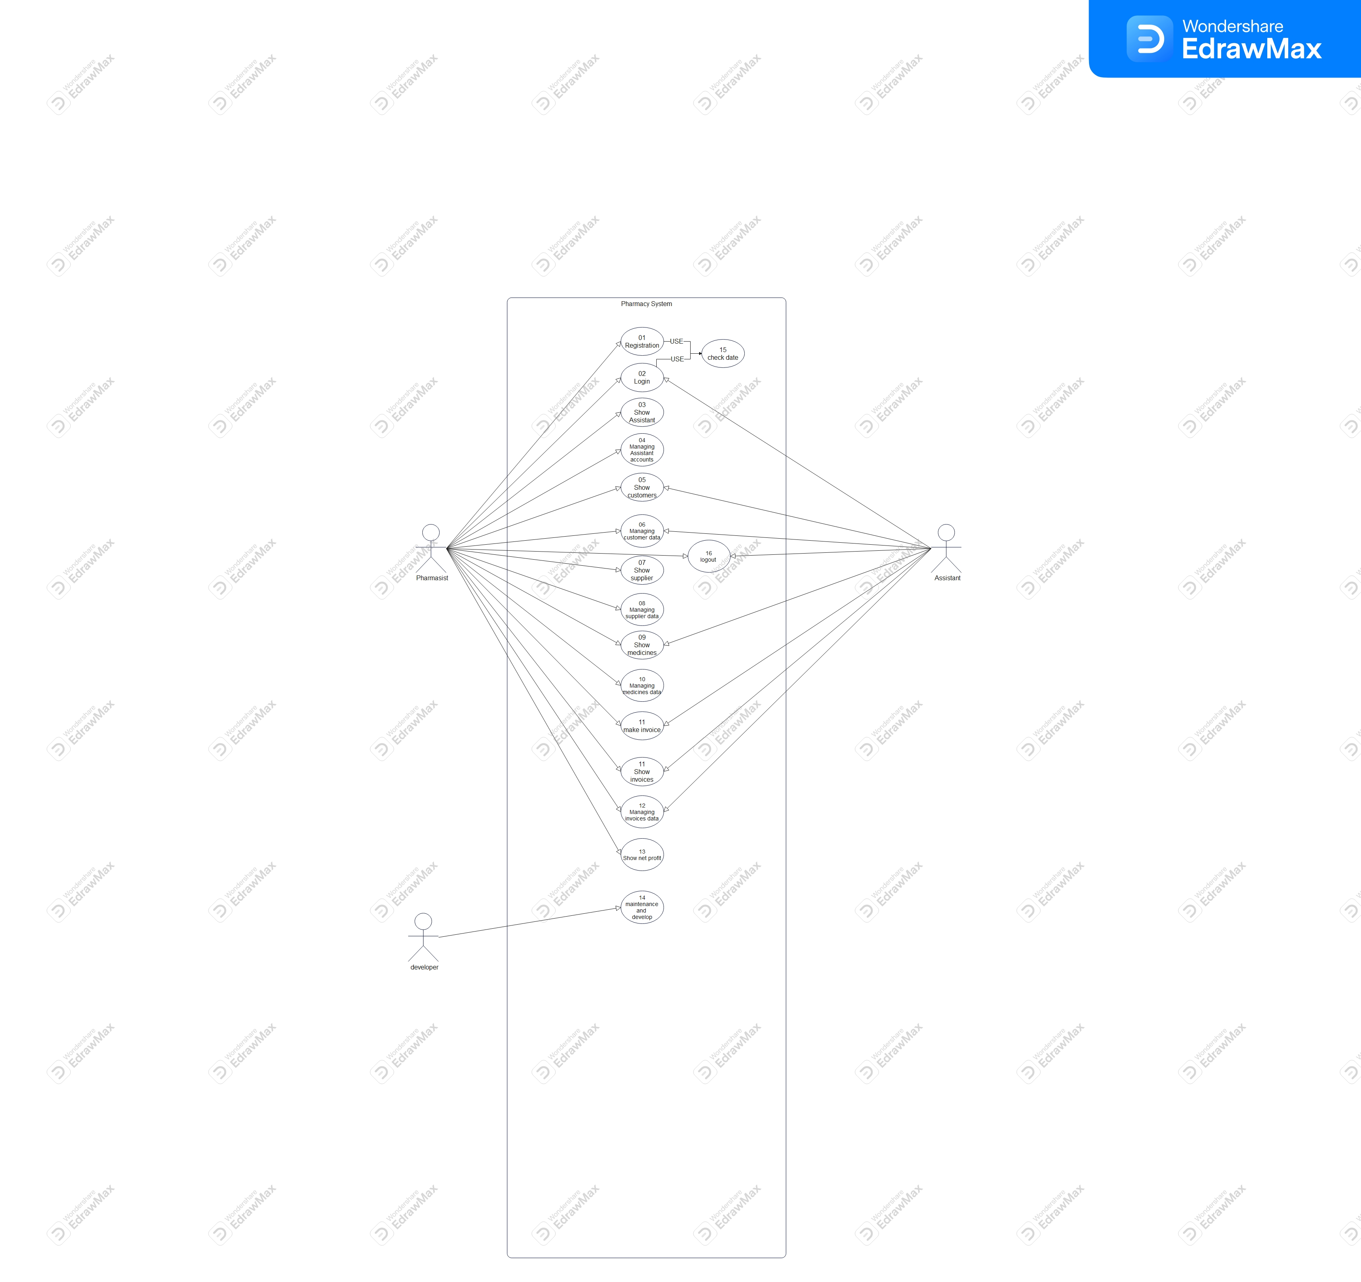

**Use Case Description Tables**

|  |  |  |
| --- | --- | --- |
| Use Case Number: | 01 | |
| Use Case Name: | Registration | |
| Actors: | Pharmasist , assistant | |
| Overview: | The goal of this use case is to record system user data and save it in database. | |
| Related use cases: | Check data | |
| Event (Stimulus): | **User Action** | **System Action** |
| 1- User Enter your data. | System given user unique number and add data to database |
|  |  |
|  |  |
| Exceptions: | If the user enter data is existed the system must not accept this data, and the system will be return message to user to tell try again with different data. | |
| Comments: |  | |

|  |  |  |
| --- | --- | --- |
| Use Case Number: | 02 | |
| Use Case Name: | Login | |
| Actors: | Pharmacist, assistant | |
| Overview: | This use case describes the steps involved in a pharmacist logging into the pharmacy system | |
| Related use cases: | Check data | |
| Event (Stimulus): | **User Action** | **System Action** |
| opens the pharmacy system. | the first interface of the electronic prescription system, and it gives the registered users |
|  | To access the system using their registered username and password. |
|  |  |
| Exceptions: | If the pharmacist forgets their password, they can click on the "Forgot Password?" link to reset their password | |
| Comments: |  | |

|  |  |  |
| --- | --- | --- |
| Use Case Number: | 03 | |
| Use Case Name: | Show Assistant | |
| Actors: | Pharmacist | |
| Overview: | Briefly describes the main purpose and outcome of the use case | |
| Related use cases: | Identifies other use cases that are directly linked to the current one. | |
| Event (Stimulus): | **User Action** | **System Action** |
| -1Patient requests refill | -1 verifies patient identity and insurance |
|  | -2 checks prescription status |
|  | -3 dispenses medication or informs patient of next steps |
| Exceptions: | Lists potential scenarios where the normal flow of the use case might be interrupted. | |
| Comments: |  | |

|  |  |  |
| --- | --- | --- |
| Use Case Number: | 04 | |
| Use Case Name: | Managing Assistant accounts | |
| Actors: | Pharmacist | |
| Overview: | These use cases describe the process of creating, updating, and deleting assistant accounts in a pharmacy system. The pharmacy manager is the actor responsible for performing these tasks. | |
| Related use cases: | Report medication side effects | |
| Event (Stimulus): | **User Action** | **System Action** |
| 1-Patient requests prescription refill | 1- verifies patient identity and insurance. |
| 2-Patient provides prescription information | 2-checks prescription status and refills if eligible. |
|  | 3-provides medication and instructions |
| Exceptions: | If the assistant information is incomplete, the pharmacy manager will be prompted to enter the missing information.  If the assistant information is invalid, the pharmacy manager will be notified of the error.  If the assistant account already exists, the pharmacy manager will be notified of the duplicate account. | |
| Comments: |  | |

|  |  |  |
| --- | --- | --- |
| Use Case Number: | 05 | |
| Use Case Name: | Show customers | |
| Actors: | Pharmacist | |
| Overview: | The use cases in this table describe the interactions between customers and a pharmacy. The customer can request a prescription refill, request medication information, pay for medication, or update their insurance information. | |
| Related use cases: |  | |
| Event (Stimulus): | **User Action** | **System Action** |
| 1- The patient requests a refill. | 1- verifies the patient's identity and insurance. |
| 2- The patient receives instructions on how to take the medication. |  |
|  |  |
| Exceptions: | Some use cases may have exceptions. For example, the *Get Prescription Refill* use case may have an exception if the prescription is not eligible for refill. | |
| Comments: |  | |

|  |  |  |
| --- | --- | --- |
| Use Case Number: | 06 | |
| Use Case Name: | Managing customer data | |
| Actors: | Pharmacist | |
| Overview: | . Adding new customers  * Updating existing customers  * Deleting customers | |
| Related use cases: |  | |
| Event (Stimulus): | **User Action** | **System Action** |
| Clicks Add Customer button | Displays Add Customer form |
| enters customer data | Validates customer data |
| Clicks Save button | Saves customer data |
| Exceptions: | If the customer does not exist, the system will return an error message. | |
| Comments: |  | |

|  |  |  |
| --- | --- | --- |
| Use Case Number: | 07 | |
| Use Case Name: | Show supplier | |
| Actors: | Pharmacist | |
| Overview: | Access and view supplier data to manage inventory | |
| Related use cases: |  | |
| Event (Stimulus): | **User Action** | **System Action** |
| 1. Pharmacist selects "Suppliers" from the menu. | 1. System displays a list of all suppliers |
| 2- Pharmacist selects a supplier from the list | 2-System displays the supplier's information |
|  |  |
| Exceptions: |  | |
| Comments: |  | |

|  |  |  |
| --- | --- | --- |
| Use Case Number: | 08 | |
| Use Case Name: | Managing supplier data | |
| Actors: | Pharmacist | |
| Overview: | Supplier data management is the practice of collecting, organizing and maintaining critical supplier information, which helps ensure smooth procurement operations. Good supplier management involves keeping track of supplier profiles, contact information, performance metrics, compliance documents (including information related to environmental, social and governance [ESG] issues) and other important data | |
| Related use cases: |  | |
| Event (Stimulus): | **User Action** | **System Action** |
| If the admin click on supplier data | System display list of options |
| Admin choose any option | System execute this option . |
|  |  |
| Exceptions: | If the pharmacist forgets their password, they can click on the "Forgot Password?" link to reset their password | |
| Comments: |  | |

|  |  |  |
| --- | --- | --- |
| Use Case Number: | 09 | |
| Use Case Name: | Show medicines | |
| Actors: | Pharmacist | |
| Overview: | A Summary of Product Characteristic (or SmPC) is a monograph for medicines written and updated by pharmaceutical companies based on their product research and knowledge. It outlines important information about medicines such as form, clinical parameters, and pharmacological properties. | |
| Related use cases: |  | |
| Event (Stimulus): | **User Action** | **System Action** |
| If the admin clicks on display data | System displays list of data |
|  |  |
|  |  |
| Exceptions: |  | |
| Comments: |  | |

|  |  |  |
| --- | --- | --- |
| Use Case Number: | 10 | |
| Use Case Name: | Managing medicines data | |
| Actors: | Pharmacist | |
| Overview: | This use case allows a pharmacist to manage medicines data in the pharmacy system. This includes adding, editing, deleting, and searching for medicines | |
| Related use cases: |  | |
| Event (Stimulus): | **User Action** | **System Action** |
| 1- Pharmacist selects the "Manage Medicines" menu option | 1-System displays the "Manage Medicines" screen. |
| 1-Pharmacist enters the medicine's name, description, dosage, and other information. | 2-System validates the data and adds the medicine to the system |
|  |  |
| Exceptions: | If the pharmacist enters invalid data for a medicine, the system will display an error message. | |
| Comments: |  | |

|  |  |  |
| --- | --- | --- |
| Use Case Number: | 11 | |
| Use Case Name: | make invoice | |
| Actors: | Pharmacist, Assistant | |
| Overview: | This use case describes the process of creating a pharmacy invoice. The user enters the details of the sale, including the customer, the items purchased, and the quantities purchased. The system then calculates the total cost of the sale and generates the invoice. | |
| Related use cases: |  | |
| Event (Stimulus): | **User Action** | **System Action** |
| 1-The user selects the "Create Invoice" menu option | 1-The system displays the invoice creation form. |
|  |  |
|  |  |
| Use Case Number: | 12 | |
| Use Case Name: | Show invoices | |
| Actors: | Pharmacist, Assistant | |
| Overview: | This use case describes the process of displaying an invoice to a customer. The customer can view the invoice details, including the items purchased, the prices, and the total amount due. | |
| Related use cases: |  | |
| Event (Stimulus): | **User Action** | **System Action** |
| 1-Customer clicks on the "Show Invoice" button | 1-System retrieves the invoice from the database. |
| 2-Customer clicks on the "View Invoice" button. | 2- System displays the invoice details |
| 3-Customer clicks on the "Close Invoice" button. | 3-System closes the invoice |
| Exceptions: | If the invoice cannot be found, the system will display an error message | |
| Comments: |  | |

|  |  |  |
| --- | --- | --- |
| Use Case Number: | 13 | |
| Use Case Name: | Managing invoices data | |
| Actors: | Pharmacist, Assistant | |
| Overview: | This use case allows the pharmacy admin to manage invoice data. This includes creating, editing, and deleting invoices. | |
| Related use cases: |  | |
| Event (Stimulus): | **User Action** | **System Action** |
| 1-he pharmacy admin selects the "Manage Invoices" menu option | 1-he pharmacy admin selects the "Manage Invoices" menu option |
| 2-The pharmacy admin clicks the "Create Invoice" button. | 2-The system displays the invoice creation form. |
| 3-The pharmacy admin enters the invoice data | 3-The system validates the invoice data. |
| Exceptions: | The invoice is not found., * The invoice data is invalid. | |
| Comments: |  | |

|  |  |  |
| --- | --- | --- |
| Use Case Number: | 14 | |
| Use Case Name: | Show net profit | |
| Actors: | Pharmacist | |
| Overview: | This use case allows a pharmacy manager to view the net profit for a given period of time | |
| Related use cases: |  | |
| Event (Stimulus): | **User Action** | **System Action** |
| 1- The user selects the "Show Net Profit" option | 1- The system displays the "Show Net Profit" dialog box. |
| 2- The user enters the start date and end date | 2- The system validates the date range |
| 3- The user clicks the "Show" button | 3- The system calculates the net profit for the specified period |
| Exceptions: | If the date range is invalid, the system will display an error message. | |
| Comments: |  | |

|  |  |  |
| --- | --- | --- |
| Use Case Number: | 15 | |
| Use Case Name: | maintenance and develop | |
| Actors: | developer | |
| Overview: | Track stock levels, reorder medication, manage expiry dates | |
| Related use cases: |  | |
| Event (Stimulus): | **User Action** | **System Action** |
| 1- Update inventory levels, search for medication, request reorder | 1-Generate reorder report, send notification for low stock, update expiration date |
|  |  |
|  |  |
| Exceptions: | Inventory discrepancy, medication recall | |
| Comments: |  | |

|  |  |  |
| --- | --- | --- |
| Use Case Number: | 16 | |
| Use Case Name: | Logout | |
| Actors: | Customer | |
| Overview: | This use case allows a customer to log out of the pharmacy system | |
| Related use cases: |  | |
| Event (Stimulus): | **User Action** | **System Action** |
| 1- The customer clicks the "Logout" button. |  |
| 2. The system logs the customer out and returns them to the login page. |  |
|  |  |
| Exceptions: | If the customer has any unsaved changes, the system will prompt them to save their changes before logging out | |
| Comments: |  | |

# **4.2** **Class diagrams**

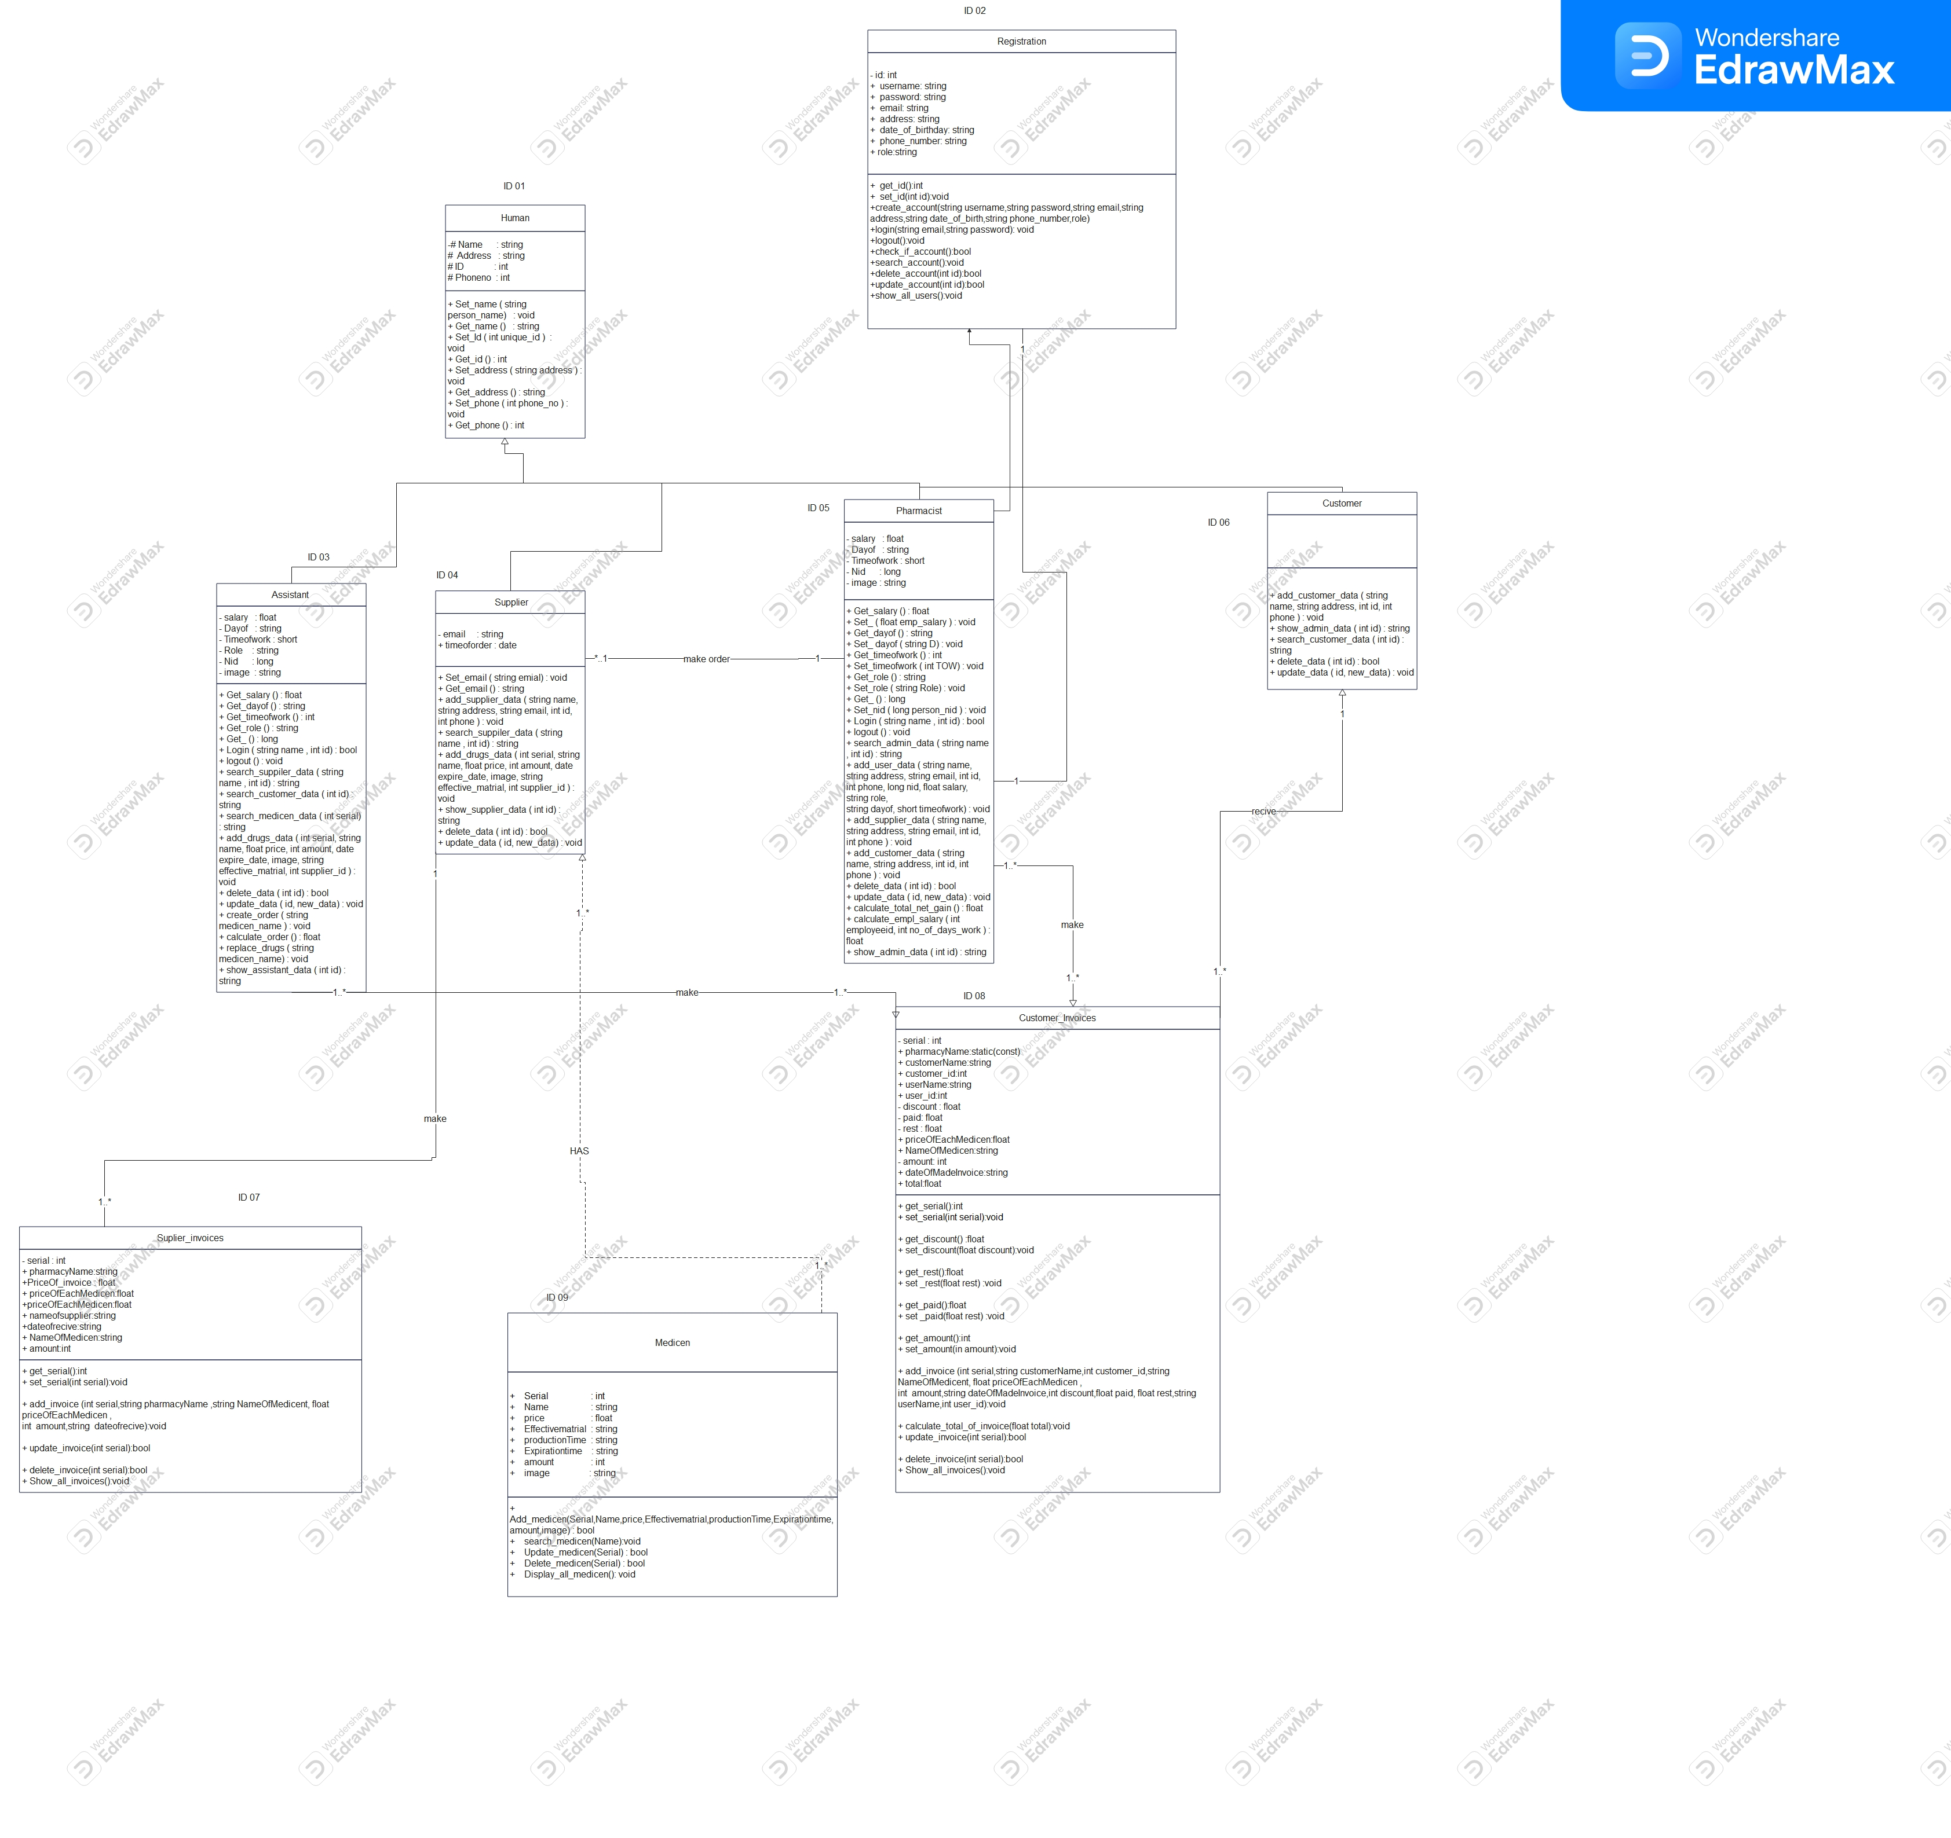

* + **Use Classes Description Tables**

| **Class ID** | **Class Name** | **Description** |
| --- | --- | --- |
| 01 | Human | An abstract class has common attributes and methods. |
| 02 | Registration | Can accessed by just admin to make an account for assistant. |
| 03 | Assistant | Save, update, delete, show, data. |
| 04 | Supplier | Save, update, delete, show, data. |
| 05 | Admin | Has access for all systems (Save, update, delete, show, data.) |
| 06 | Customer | Save, update, delete, show, data. |
| 07 | Supplier_invoices | store, update, delete, show, data. |
| 08 | Customer_Invoices | store, update, delete, show, data. |
| 09 | Medicine | store, update, delete, show, data. |

# 

# **4.3** **Sequence diagrams**

* + List Sequence diagrams for all requirements. Provide each Sequence an ID.
  + Not necessary diagram per requirement. May be better to merge more than a flow. Typically, 1 sequence diagram per your use case table.
  + Make sure that each object in the sequence diagram has a corresponding class in the class description table above. If not, it will be REJECTED.
  + Put actual function calls with proper parameters and return types corresponding to class diagrams.
    - Please always specify the parameters in the call, matching the class diagram.

**Inseruet Sequence diagrams Images Here**

# **4.4 Physical Entity-Relationship Diagram**

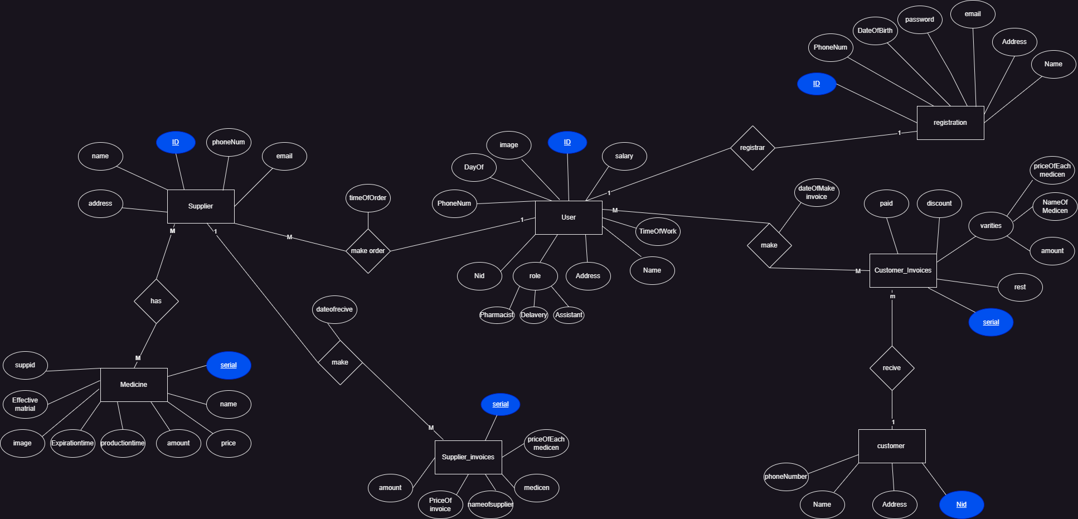

# **Ownership Report**

|  |  |  |
| --- | --- | --- |
| **Student ID** | **Student Name** | **What the student done** |
| 42110179 | *Ahmed Hesham Abdelfattah* | *SRS (Suppliers, payment, security),*  *ERD*  *Use case.*  *Class diagram (medicine, supplier invoice)* |
| 42110462 | *Eslam Ali* | *SRS (customer, medicine, attend, reliability),*  *ERD*  *Use case.*  *Class diagram (human, Pharmacist, assistant, supplier)* |
| 42110245 | *Lamia Ahmed* | *SRS (customer, medicine, attend, reliability),*  *ERD*  *Use case.*  *Class diagram (customer invoice)* |
| 42110014 | *Mariem Mohamed* | *SRS (Pharmacist, employee, usability),*  *ERD*  *Use case.*  *Class diagram(registration)* |
| 42110277 | *Mirna Hatem* | *SRS (registration, logout, login, performance),*  *ERD*  *Use case*  *Class diagram(registration)* |
| 42110326 | *Solafa Ibrahim* | *SRS (registration, logout, login, performance).*  *ERD.*  *Use case.*  *Class diagram (customer invoice).* |